THE WALPOLE CONTENT PROGRAMME
A Guide for Members 2019

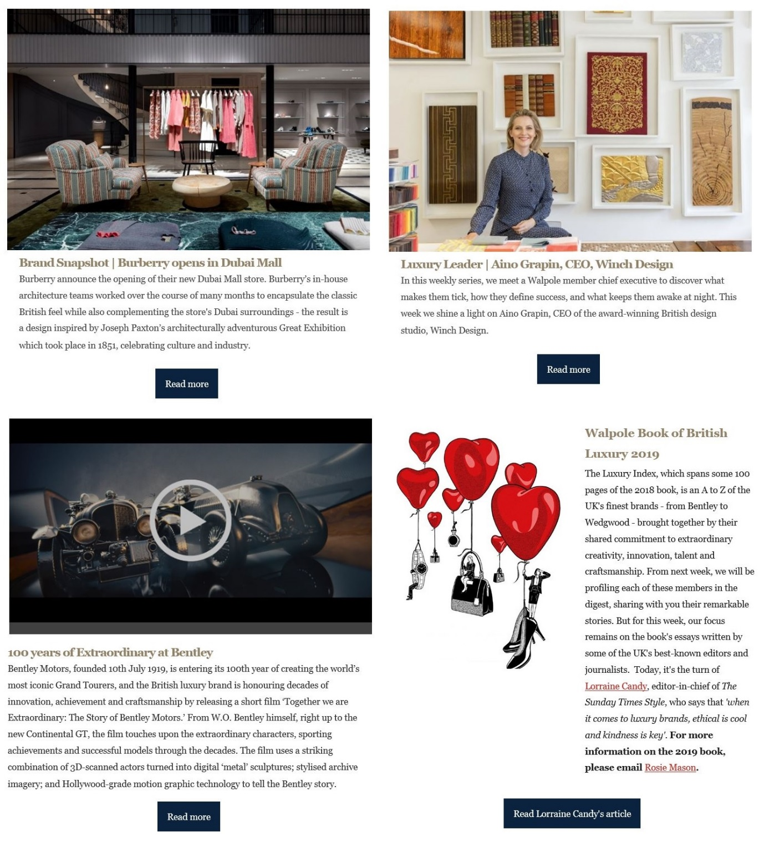
About Walpole’s Content Programme
Walpole’s powerful content programme is designed to provide all members with the opportunity to amplify their business projects and initiatives; to tell the stories of the people behind their brands; and to highlight luxury products, services, campaigns and collaboration opportunities to an audience of over 24,000. Published in our Daily Luxury Digest, and shared on our website and social media platforms, the programme also includes an invaluable edit of the day’s important news in luxury and a Walpole story, helping us put British luxury at the front of the agenda.
Daily Luxury Digest
The essential early morning briefing for luxury professionals, the Daily Digest is a digital round up of key luxury news, interviews and events from the past 24 hours.
Arriving in inboxes first thing each day, it showcases members’ latest activities, profiling luxury executives from across the sector and shining a light on brands’ most recent innovations. Current international luxury news stories and updates from Walpole are also shared in this industry-leading daily service.
thewalpole.co.uk and Walpole social media
This content is also hosted on Walpole’s website, thewalpole.co.uk, and across our social media platforms on Instagram, Twitter and Facebook, with a combined reach of over 21,000 subscribers and followers.
There are a multitude of opportunities for members to get involved in the Walpole Content Programme. Please see below for more.
Opportunities
Life in Luxury – an interview with a Walpole member exploring their working life and examining what makes the sector and its people tick.
Brand Snapshot – A news piece about what’s hot and happening right now.
Member of the Week – A profile of members featured in the Walpole Book of British Luxury
Five Minutes with the Founder – an interview with a current Brand of Tomorrow founder.
Woman in Luxury – Business and career advice from the women in Walpole’s membership.
Luxury Leader (formerly My Life’s Work) – CEO/MD-level profile opportunity.
The Pitch – an opportunity for Media Members (and relevant others) to profile their publication and present partnership/sponsorship opportunities in an engaging way.
Strategic Partner Profile – an advertorial-style feature for Strategic Partner and Sponsors to present their services and discuss how they work with luxury brands and Walpole.
Strategic Partner Insights – indepth advice from a brand on their area of expertise, which positions the partner as an authority on the subject, and could include analysis/study/statistics/case studies.
Seasonal takeovers – content themed around external and Walpole events.
Guidelines
All of the features can be completed via email for ease. Return your copy and image(s) to content@thewalpole.co.uk. The Walpole comms team can be reached on and jenni.rayner@thewalpole.co.uk, carly.vonspeyr@thewalpole.co.uk and celandine.wade@thewalpole.co.uk.
Life in Luxury
‘Life in Luxury’ explores the everyday working lives of all areas of Walpole’s membership from makers to merchandisers, PR to HR, chefs, housekeeping, designers, gardeners, layers and everyone in between, this feature encourages members share their working day - their life in luxury – to examine what makes the sector and its people tick.
This opportunity enables members to profile the range of employees and roles in their organisations and it supports one of Walpole’s pillar of encouraging young people to consider one of the many and diverse careers available in the luxury sector.
- Full name, job title, company name?

- Tell us what you do?

- What does a typical working day look like for you?

- What do you like most about your job?

- Least?

- What attracted you to the luxury / creative sector specifically?

- What was your path to the role you have now? (on the job training, professional qualifications, apprenticeship)?

- What advice would you give someone looking to get into the luxury / creative sector?

Please include a hi-res head shot and a brand/product shot
The photos do not have to be professionally shot, but should be in focus with good lighting. LANDSCAPE IMAGES ARE PREFFERED

Brand Snapshot

‘Brand Snapshot’ is an opportunity for Walpole members to promote a current campaign, initiative, product launch or key piece of news and tell readers more about what their company story is right now.
See an example Brand Snapshot here: http://www.thewalpole.co.uk/member_news/brand-snapshot-temperley-london/
Please send 200-300 words and at least one photo to accompany the piece. LANDSCAPE IMAGES ARE PREFFERED
You may want, but don’t have to include:
- A press release

- Info on brand ambassadors or VIPs involved

- Photographer information (if you've shot a new campaign for example)

- Social media links/hashtags

- Any calls to action/how to get involved

- Links to any filmed content/brand film/show reel

Brands of Tomorrow:
Five Minutes with the Founder
‘Five minutes with the Founder’ is a profile opportunity for the founders/CEOs of Brands of Tomorrow and new businesses amongst the membership. The aim of the Q&A is to focus on the personality and entrepreneurial motivation behind new British luxury brands, showcasing the individual(s) behind successful new businesses.
• Briefly describe your company
• Tell us the story of how you built your brand
• Why did you choose to set up your business in the luxury sector?
• What is your favourite thing about your job?
• What and/or who is your source of inspiration and motivation?
• If you could have any other job in the world what would it be?
• If you could do something differently in your career what would it be?
• Where do you see yourself and your company in 10 years’ time?
• What does success look like to you?
• What advice do you have for any young entrepreneurs looking to start their own business?
Please include a hi-res, landscape, headshot with your answers. If you are a co-founder you can both answer but please indicate who said what.

Woman in Luxury

‘Woman in Luxury’ is a profile opportunity specifically for women in senior positions at Walpole member brands.
It is a known fact that the visibility of female role models can positively impact the aspirations of the women around them. This weekly piece of content asks women working in the luxury industry for advice they wish they had been given at key points in their career.
- Full name, job title, company name

- Tell us a bit about your company and role?

- How did you get into it? (please provide some detail on your career path and progression including bumps in the road if there were any/you want to)

- What advice do you wish you had been given or would you go back and give yourself at key points in your career?
These key points can include, but are not limited to your experience of:
    - Making your mark in your first/second job
    - Negotiating your first pay rise or promotion
    - Going for your first ‘big’ job
    - Leaving corporate life to start your own business
    - Returning to work after parental leave
    - Going freelance
    - Negotiating a significant business deal

Please include a hi-res head shot with your answers. The photos do not have to be professionally shot, but should be in focus with good lighting. LANDSCAPE IMAGES ARE PREFFERED

Luxury Leader
‘Luxury Leader’ is a profile opportunity for Walpole member chairmen/CEO/managing director level executives. The aim of the Q&A, which is conducted via the form below, is to shine a light on top business leaders in British luxury and discover some of the secrets to their success.

- Name:

- Job title:

- Company name:

- Biography (100 words):

- What does British luxury mean to you?

- What's your vision for the company?

- What do you see as the future of luxury?

- What inspires you? OR What was your big break?

- What piece of advice would you give to someone entering the luxury industry now?

- In a parallel life, what would you be doing?

- What’s your best luxury under £10? OR What’s your favourite luxury?

Please include a hi-res, preferably landscape, headshot with your answers.

The Pitch
This editorial feature is predominantly for Walpole’s media members (it’s open to other members provided the opportunity is right) and aims to profile both the publication/company and a specific sponsorship, partnership or advertising opportunity to the rest of the membership.
The Pitch should introduce your publication/company to our readership, explain its editorial/commercial focus and readership/customer base; how and why luxury brands should engage with it and explain a bit about the sponsorship or advertising opportunity in an engaging way. It should be a conversation starter, not a sales deck or a list of packages and prices
- Full name, job title, company/publication name

- Tell us a bit about what your company does OR what your publication’s focus is

- What are you working on right now? (this should include the partnership/sponsorship opportunity information: why is it amazing, why would luxury brands want to align with it and what’s the benefit for them?)

- What could Walpole members do to support/get involved?

Please include a hi-res image with your answers. LANDSCAPE IMAGES ARE PREFFERED

Strategic Partner Profile
Walpole has long-standing relationships with top tier companies with unique expertise and who share Walpole’s aims to promote British luxury. The content programme for this group of the membership serves to share research, insights and trend analysis relevant to Walpole’s membership and the boarder luxury sector.
In addition to any promotion around an agreed event activation, we will also publish one promotion piece about your organisation, its objectives and what you would like to get from your Walpole membership.
- Full name, job title, company name

- Tell us a bit about what your organisation does? (and why are you’re better than other player in your sector/what’s your special thing)

- How do you work with luxury brands?

- How do you work with/help Walpole (i.e. you supply the beautiful paper is used for Walpole’s print work/you design the yearbook/provide legal advice)
AND/OR
- Why do you want to work with Walpole (why did you sponsor an event/award category and how will it help you meet your business objectives)

Please answer the questions below and include a hi-res head shot or other relevant image with your answers. LANDSCAPE IMAGES ARE PREFFERED

Seasonal takeovers
The Walpole content programme regularly features ‘takeovers’, with the whole of our focus on a specific event or activation, for example members’ activities around Christmas, or a look at their summer plans. Details of these takeovers are communicated regularly through the Daily Digest.
Our three main seasonal takeovers are:
Work/Life Resolution (January)
A focus on the personal and professional New Year resolutions of members.
A Summer of Luxury (August)
A focus on member’s warm-weather activities, events and news, as well as individual’s personal summer holiday experiences.
21 Days of Christmas (December)
A focus on member’s festive events, gift guides and activities, as well as individual’s personal plans for Christmas.

Seasonal takeovers calendar
*all takeovers are subject to change and participation is not guaranteed

JANUARY
Work/Life Resolution
Burns Night

FEBRUARY
Valentine’s Day
Walpole Brands of Tomorrow launch
Walpole Summit

MARCH
London Design Week
Mother’s Day
Walpole Book of Luxury launch

APRIL
Easter

MAY
London Craft Week
The RHS Chelsea Flower Show

JUNE
Ascot

JULY

AUGUST
A Summer of Luxury

SEPTEMBER
London Design Fair

OCTOBER
London Cocktail Week
Halloween
Walpole New York Trade Mission

NOVEMBER

Walpole British Luxury Awards

DECEMBER
21 Days of Christmas

