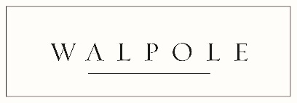
A Season of Luxury | How are you and your brand celebrating Christmas?
Join Walpole’s second-annual Christmas content campaign, beginning on Monday 2nd December, as we go behind the scenes of British luxury to discover how its people and brands are celebrating the festive season – from favourite Christmas traditions and present wish lists to festive events and gift guides – all of which will be shared across our Daily Digest and digital and social channels to a combined readership of 30,000.
To get involved, please email content@thewalpole.co.uk with your images (preferably landscape), answers to the below questions and/or press releases, brand information or event invitations/special offers. This initiative is open to all Walpole members.
This initiative is open to all Walpole members.
For individuals: Please answer one or more (or all!) of the below:
- All I want for Christmas is…

- How will you be celebrating Christmas this year?
- Your favourite Christmas tradition?
- Favourite festive film or song?
- Best place to enjoy the Christmas atmosphere?
Please include your headshot / image with your answers.
For Brands: Please send over information / press releases / images on ANY of the below:
- Your brand’s must-have gifts?
- Information on special offers
- Festive customer events
- For fashion/accessories/beauty/skincare brands: Winter beauty or style advice?
- For hospitality brands: Top festive travel/dining destinations
- Latest winter product launches

